How to reset your password
Step 1
Go to the Campus Portal and login (http://campus.ccsd.net)
Note: If you are unable to login to the Campus Portal contact the District Help Desk at 702-799-3300 option 1).
Once logged in:
- Look for "User Account," and select "Contact Preferences.”
- Verify that you have an email address listed that you have access to or update the email address as needed. Make sure you check the box allowing teachers to email you.
- Click "Save"
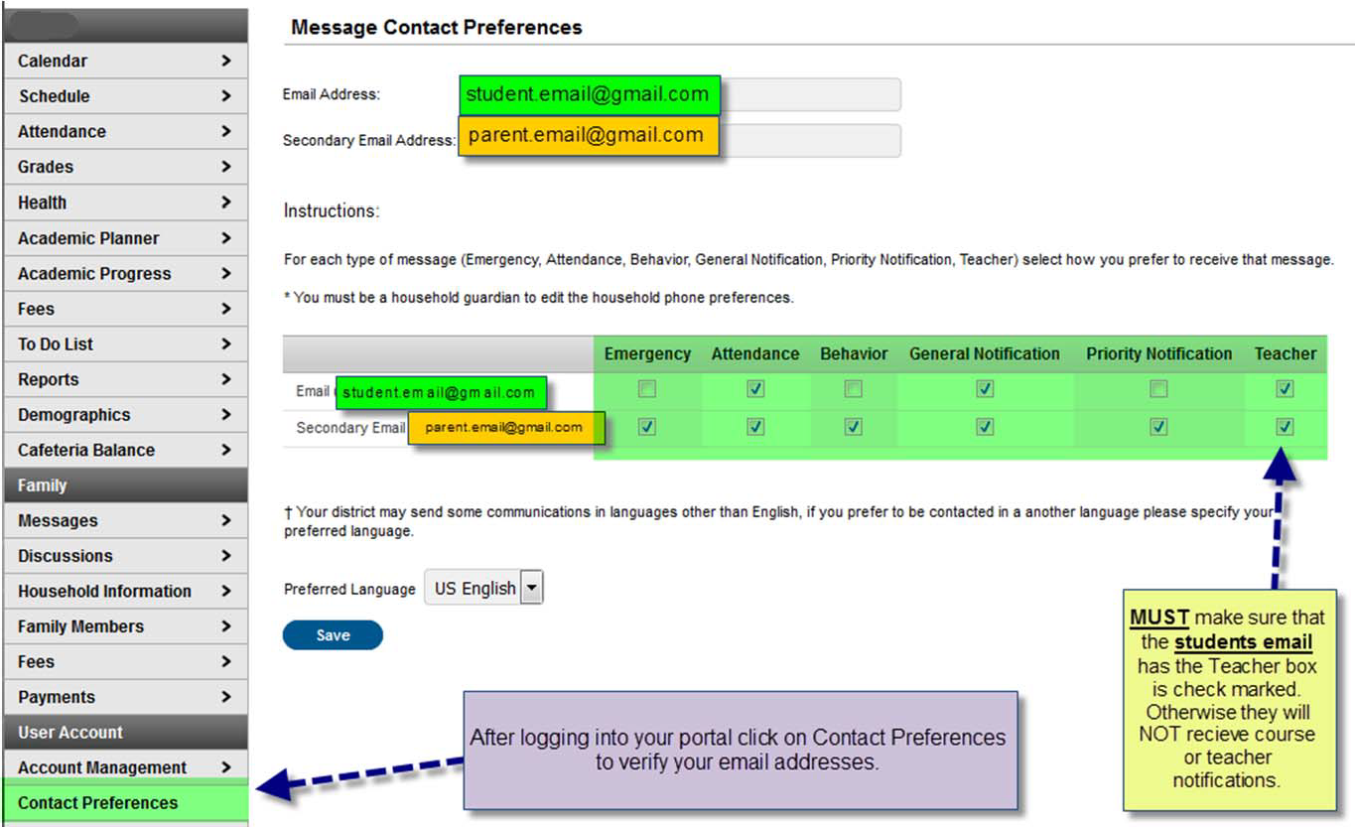

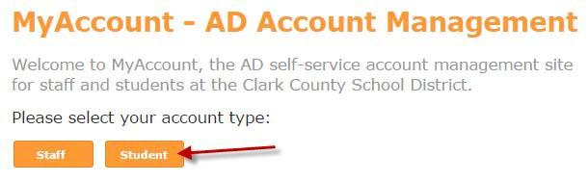
Step 2
- Recover your password.
- Go to
- http://Myaccount.ccsd.net
- Select "Student"

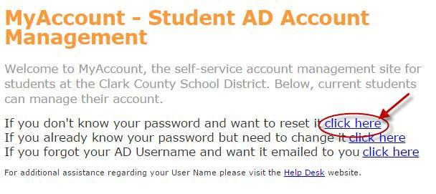
- Click the first option: "If you don’t know your password and want to reset it click here"

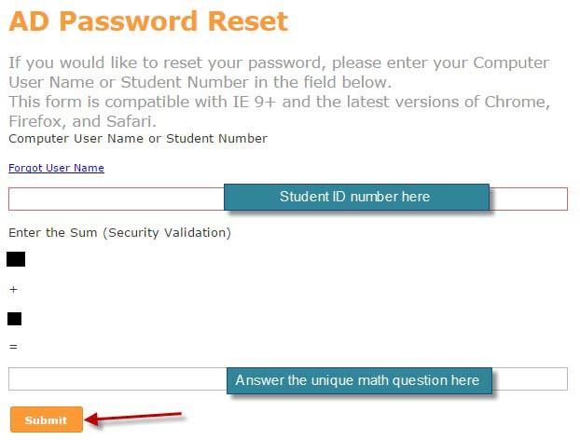
- Enter your "Student Number"
- Enter the "Sum" of the "Security Validation"
- Click "Submit"
- You should receive an email within 15 minutes at the email address listed in the Campus Portal.
- Click the link in the email to update your password.

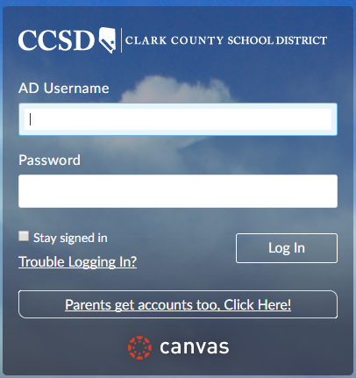
Step 3
- Login to Canvas (ccsd.instructure.com)
- Username: your student number
- Password: the AD password you just set

